Multiple-choice section – choose the correct answer

Question 1 [7.1]

For the triangle shown, which of the following represents the ratio  for the acute angle that is *not* marked *a*?

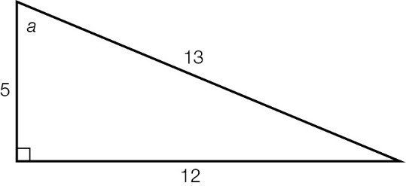

A B C D 

Question 2 [7.2]

If the sine ratio for the angle *a* = , the value of the unknown side *x* is:

**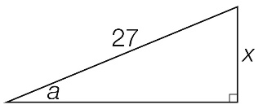**

A 3 B 9 C 15 D 27

Question 3 [7.4]

Which equation can be used to find the value of θ in the diagram?

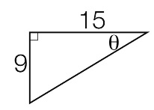

A cos(θ) = B sin(θ) = C tan(θ) = D tan(θ) =

Question 4 [7.5]

A 9.5 m tree casts a shadow across the ground. If the angle of elevation of the sun is 49°, the length of the shadow is closest to:

A 1.2 m B 6.2 m C 7.2 m D 8.3 m

Question 5 [7.5]

A bird flies for 2.5 km on a bearing of 160°T from its nest. What true bearing should the bird follow to get back to its nest?

A 180°T **B** 020°T **C** 340°T **D** 160°T

Question 6 [7.3]

The value of *k* could be found by using which of the following equations?

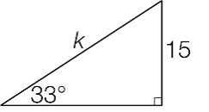

A sin(33°) =  B cos(33°) =  C sin(33°) =  D tan(33°) = 

Multiple-choice results: \_\_\_ / 6

Short answer section

Question 7 3 marks [7.3]

A footy player standing 30 m away from the goal post kicks the ball. The ball hits the top of the 15 m high goal post. At what angle, to the nearest degree, did the footy player kick the ball?

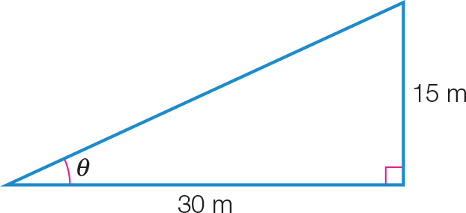

Question 8 5 marks [7.1]

You are given the following diagrams.

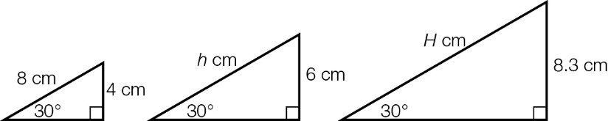

**(a)** Use trigonometry to find the values of *h* and *H*.

**(b)** Explain how you could have found these values without using trigonometry.

**(c)** What would be the height of a triangle similar to the first two that has a hypotenuse of length 21.6 cm?

Question 9 6 marks [7.3]

Find the value of the unknown lengths, correct to 1 decimal place.

**(a)**

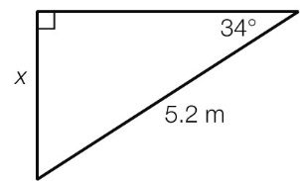

**(b)**

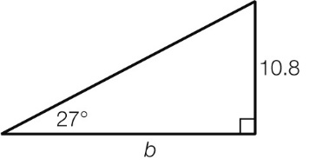

**(c)**

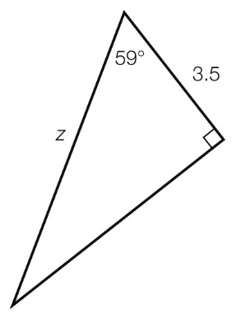

Question 10 6 marks [7.4]

Find the value of θ, correct to the nearest degree, in each of the following.

|  |  |  |
| --- | --- | --- |
| **(a)**  ACPM9_PR_7_11tf | **(b)**  ACPM9_PR_7_12tf | **(c)**  ACPM9_PR_7_12tsa |

Question 11 3 marks [7.5]

A builder has to construct a multi-storey parking area in a shopping centre. The height between each floor is 10 feet. If the angle of elevation of the straight ramp is 20°, what will be the length of the ramp (correct to 2 decimal places)?

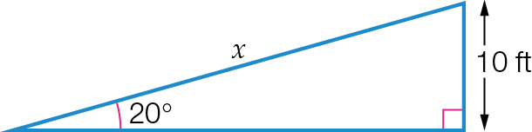

Question 12 5 marks [7.5]

Sam, who is standing on the top of a cliff, sees two yachts in a direct line in front of her at angles of depression of 24.7° and 41.9°. If Sam is 75 m above water level, find the distance between the yachts, correct to 1 decimal place.

Question 13 6 marks [xx]

A spaceship is at a height of 25 feet above John. One end of the ship is at angle of 15° and the other end at an angle of 21°. What is the total length of the spaceship, correct to 1 decimal place?

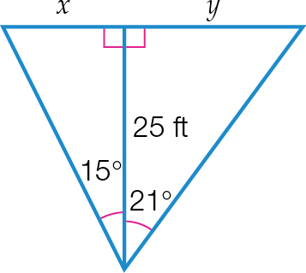

Question 14 6 marks [7.3]

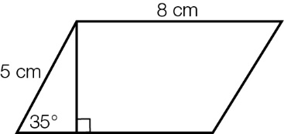

(a) Find the perpendicular height of the parallelogram above to 2 decimal places.

(b) Find the perimeter of the parallelogram.

(c) Find the area of the parallelogram, stating your answer correct to 2 decimal places.

(d) If the parallelogram is straightened up to give a 5 cm × 8 cm rectangle, find the percentage change in area. Make sure you state whether the change represents an increase or a decrease compared to the parallelogram, and state your answer correct to the nearest whole-number percentage.

Short answer results: \_\_\_ / 40

Extended answer section

Question 15 9 marks [7.5]

Lara is standing in the middle of a 15 m wide city street. Directly to her right is a building that has an angle of elevation of 79° from the ground to the top of the building. Directly to her left is a building that has an angle of elevation to the top of 83°.

**(a)** Draw a diagram of the information provided.

**(b)** Find the heights of the buildings, correct to 1 decimal place.

**(c)** Lara realises she measured the width of the street incorrectly as she did not take account of the footpaths. If the correct distance between the buildings is 18.2 m, recalculate the heights of the buildings. (Lara is still at the middle point between the buildings.)

Question 16 7 marks [7.5]

A scout walks 1.6 km from base camp on a bearing of N35°E, then walks 2.3 km on a bearing of N20°E.

**(a)** Draw a diagram showing this information.

**(b)** How far east is the scout from the base camp, correct to 1 decimal place?

**(c)** How far north is the scout from the base camp, correct to 1 decimal place?

Extended answer results: \_\_\_ / 16

TOTAL test results: \_\_\_ / 62